# Outline

# Cross Validation

## K-Fold Cross-Validation

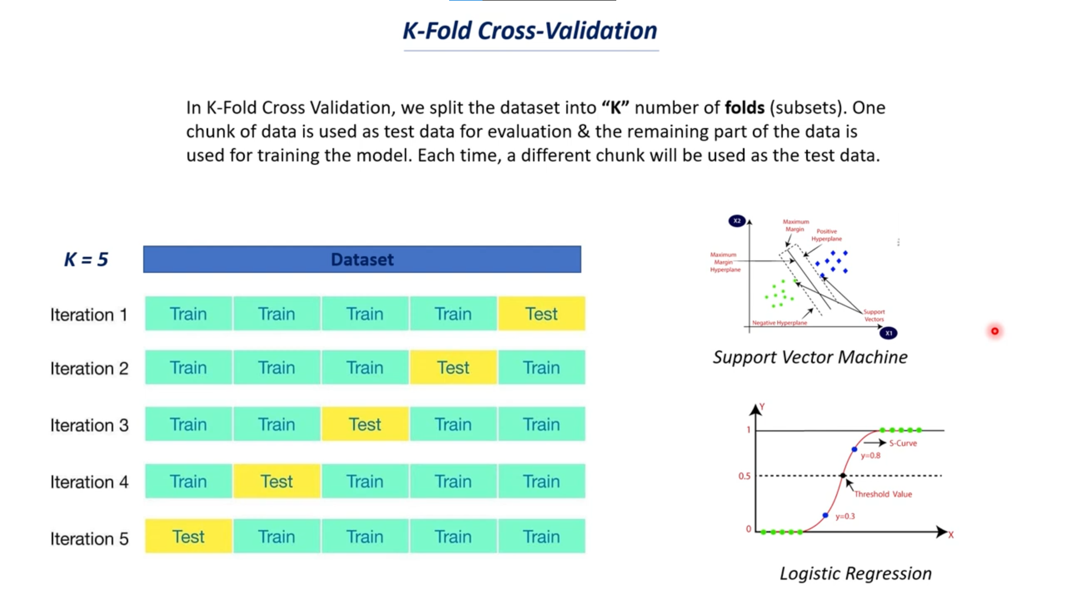

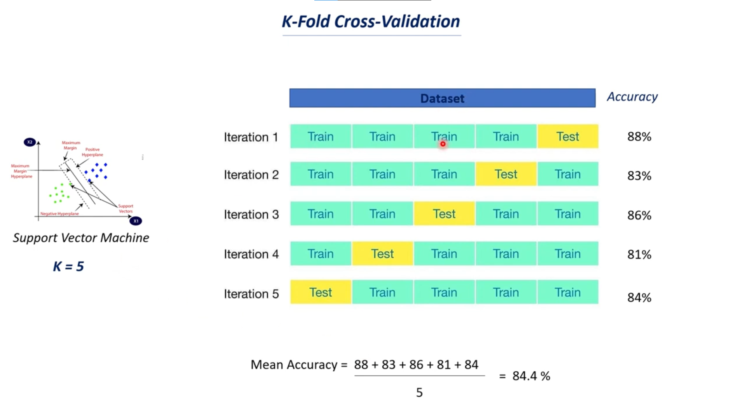

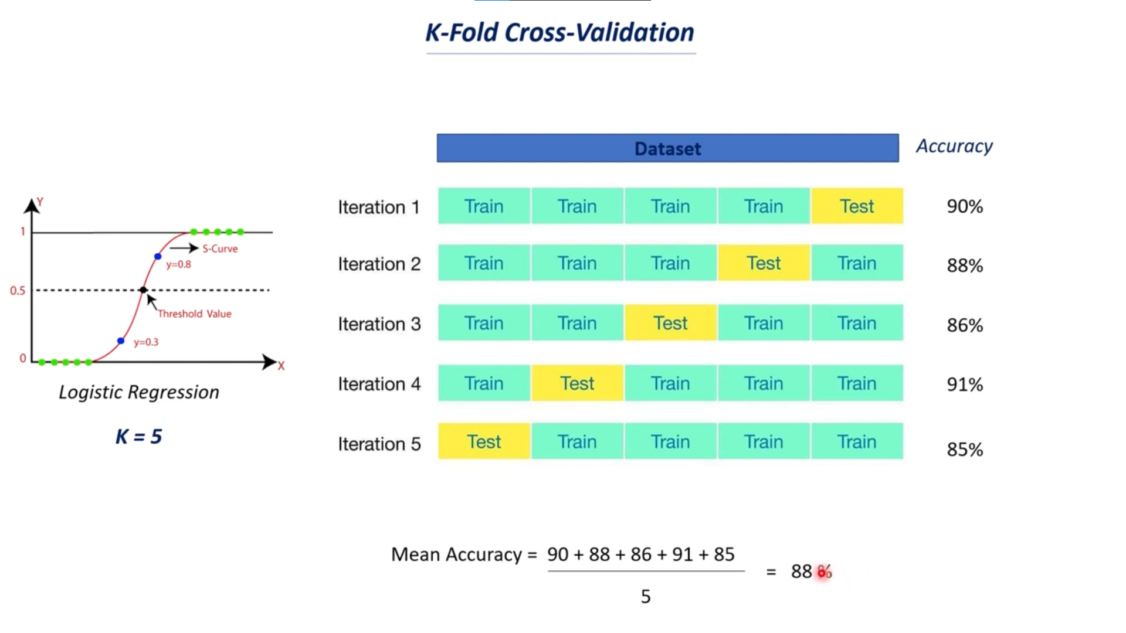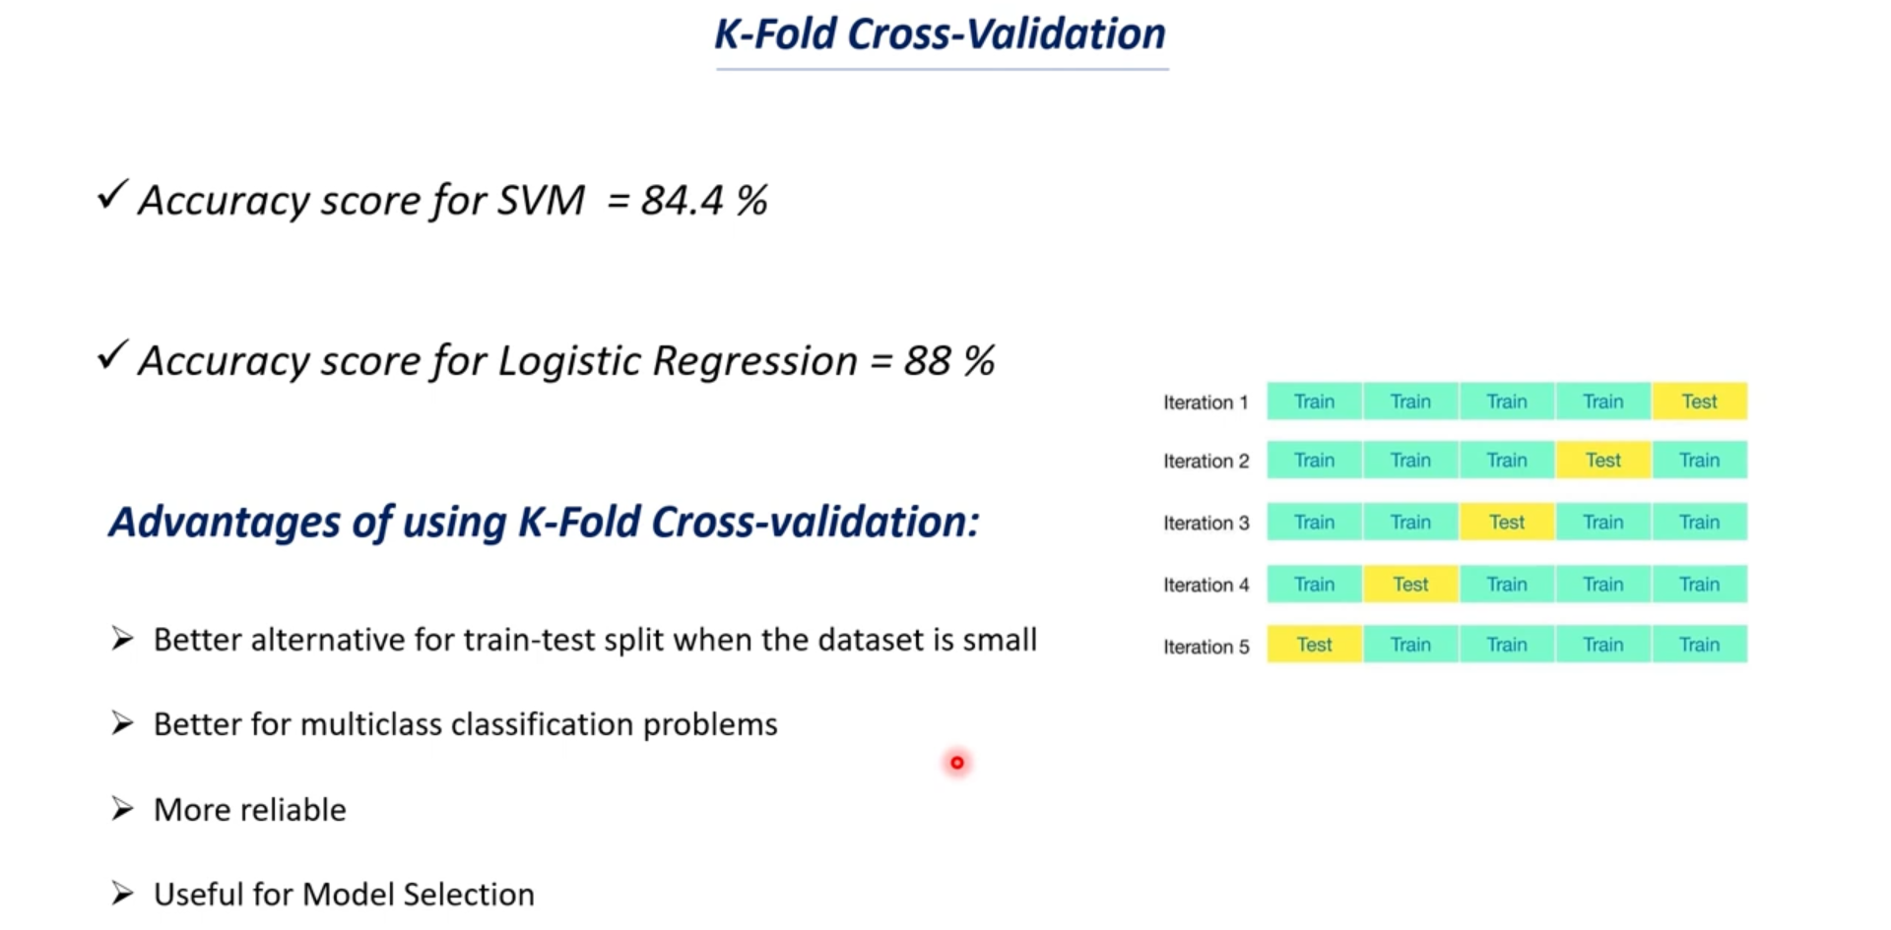

# Hyperparameter Tuning

## GridSearCV and RandomizedSearchCV

# Evaluation metrics